**Assignment 7.5**

**Problem Statement:**

Write a map only job for the word count program and set the output format as sequence file. Note: You can use the dataset of your choice.

**Input:**

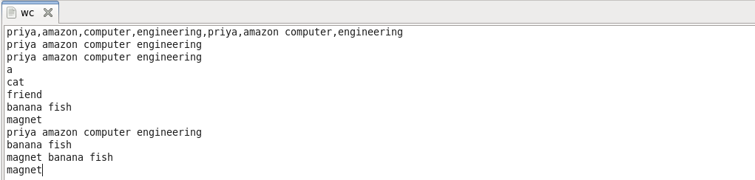

**Program:**

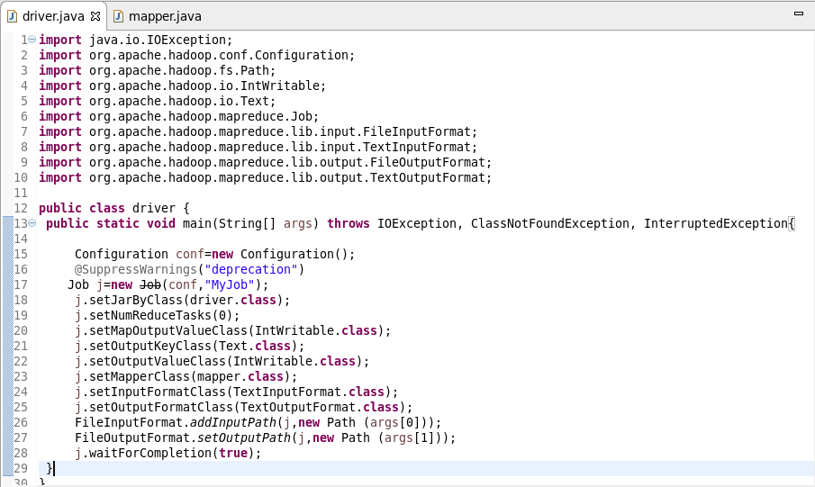

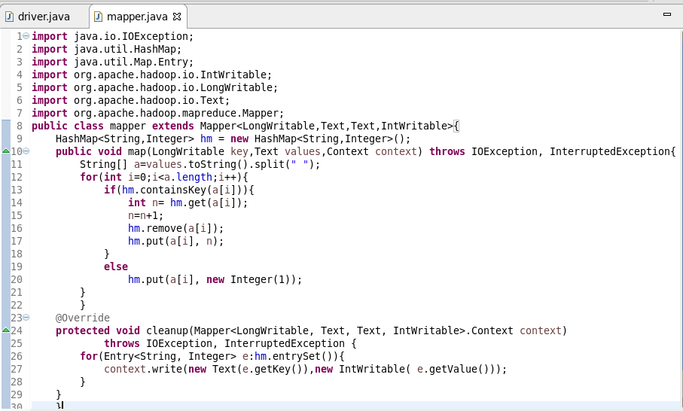

**Output:**

